**Time Management Application:**

**This application is coded in a C# language on visual studio using windows presentation Foundation. This program allows users to develop to manage users record their modules, weeks in semester, record hours spent on each module and calculating students study hours.** **This README file provides an overview of the code structure and how to use the application.**

**Overview:**

**The Time Management Application has been developed as a tool for users to keep track of their classes and modules throughout the course of a semester. It offers you to add modules, track how much time you spend on each module every week and compute your remaining self-study hours depending on your inputs.**

**Code structure:**

**MainWindow.xaml and MainWindow.xaml.cs :**

**The MainWindow.xaml file uses XAML to represent the graphical user interface of the program (UI). It has textboxes for providing module data, buttons for adding modules and logging hours, a list box for showing components, and data fields for the semester length and start date.**

**The C# logic for the application's functionality can be found in the code-behind files MainWindow.xaml.cs. It manages events such as the addition of modules, tracking hours, and calculating self-study hours remaining. This is what the form looks like:**

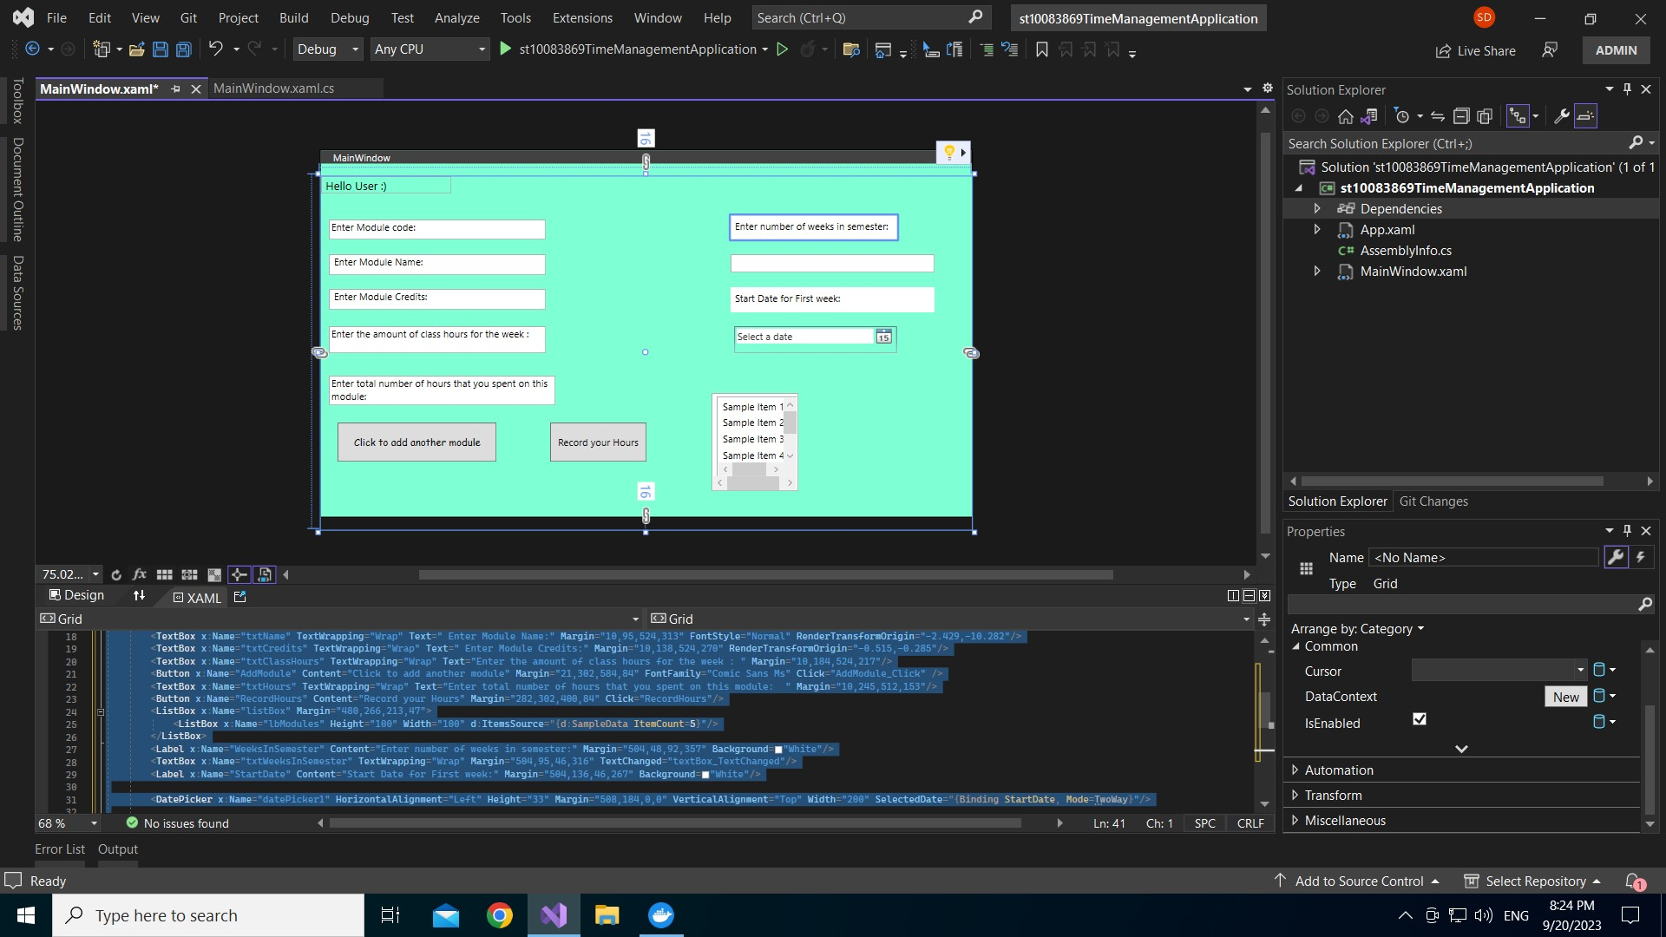

**TimeManagementLib Folder**

**This folder contains the application's backend logic in the form of C# classes. Here's what each class does:**

**Module: An educational course with attributes such as code, name, credits, weekly class hours, and a list of logged hours.**

**Recorded Hours: The number of hours spent.**

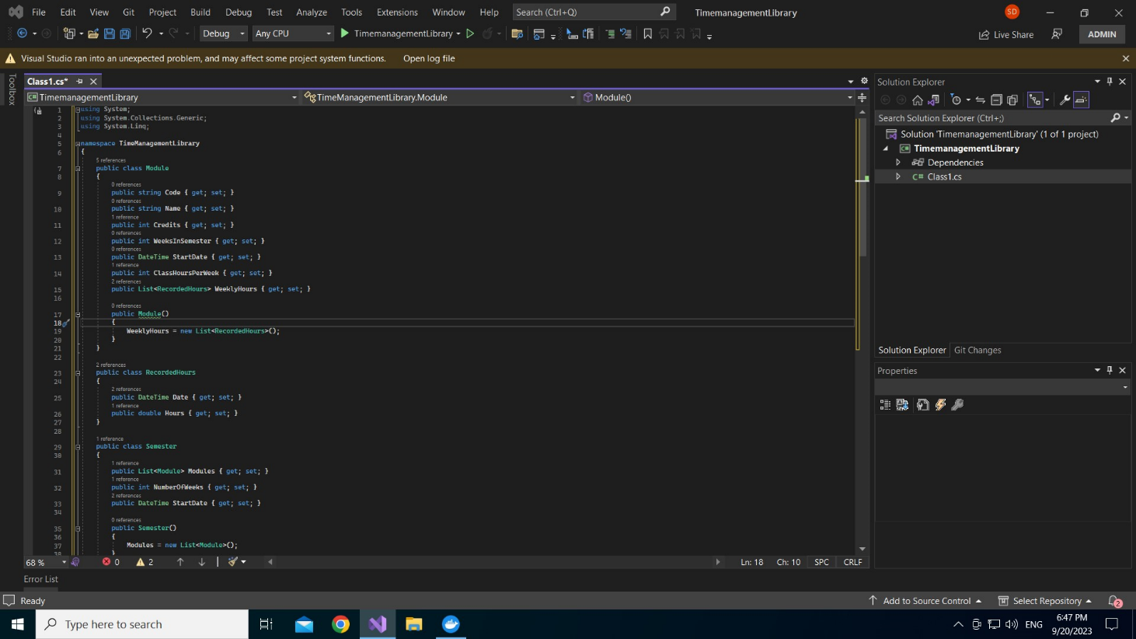**Semester: A semester can be summed up by a list of modules and features such as the number of days, of weeks and start date. It also includes a system to calculate the number of self-study hours remaining.**

**How to Use:**

**To use the Time Management Application, follow these steps:**

**Follow these steps to use the Time Management Application:**

**insert each of the following module data in the textboxes at the top of the window:**

**Module code**

**Module name**

**Module credits**

**Class hours per week**

**Click the "Click to add another module" button to add the module to the list.**

**In the "Enter total number of hours" textbox, input the sum of the number of hours worked on the chosen module for each day of the week.**

**To keep track of the hours, click the "Record your Hours" option. The application that you are using will compute and show the number of self-study hours remaining for the specified module. Using the input fields given, you can also specify the total number of weeks in the semester and the start date.**